Flowchart

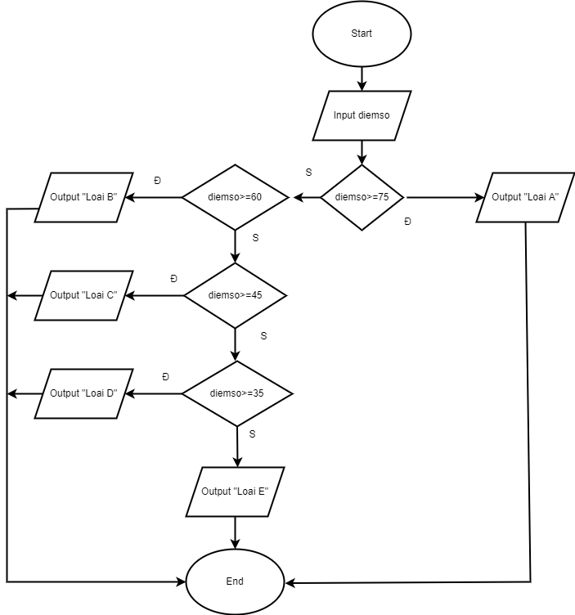

Pseudo-code

Cách 1:

Begin

Input diemso

IF (diemso>=75) THEN

Output” Loai A”

End IF

IF(60<=diemso) THEN

Output” Loai B”

End IF

IF(45<=diemso) THEN

Output” Loai C”

End IF

IF(35<=diemso) THEN

Output” Loai D”

ELSE

Output”Loai E”

End IF

End